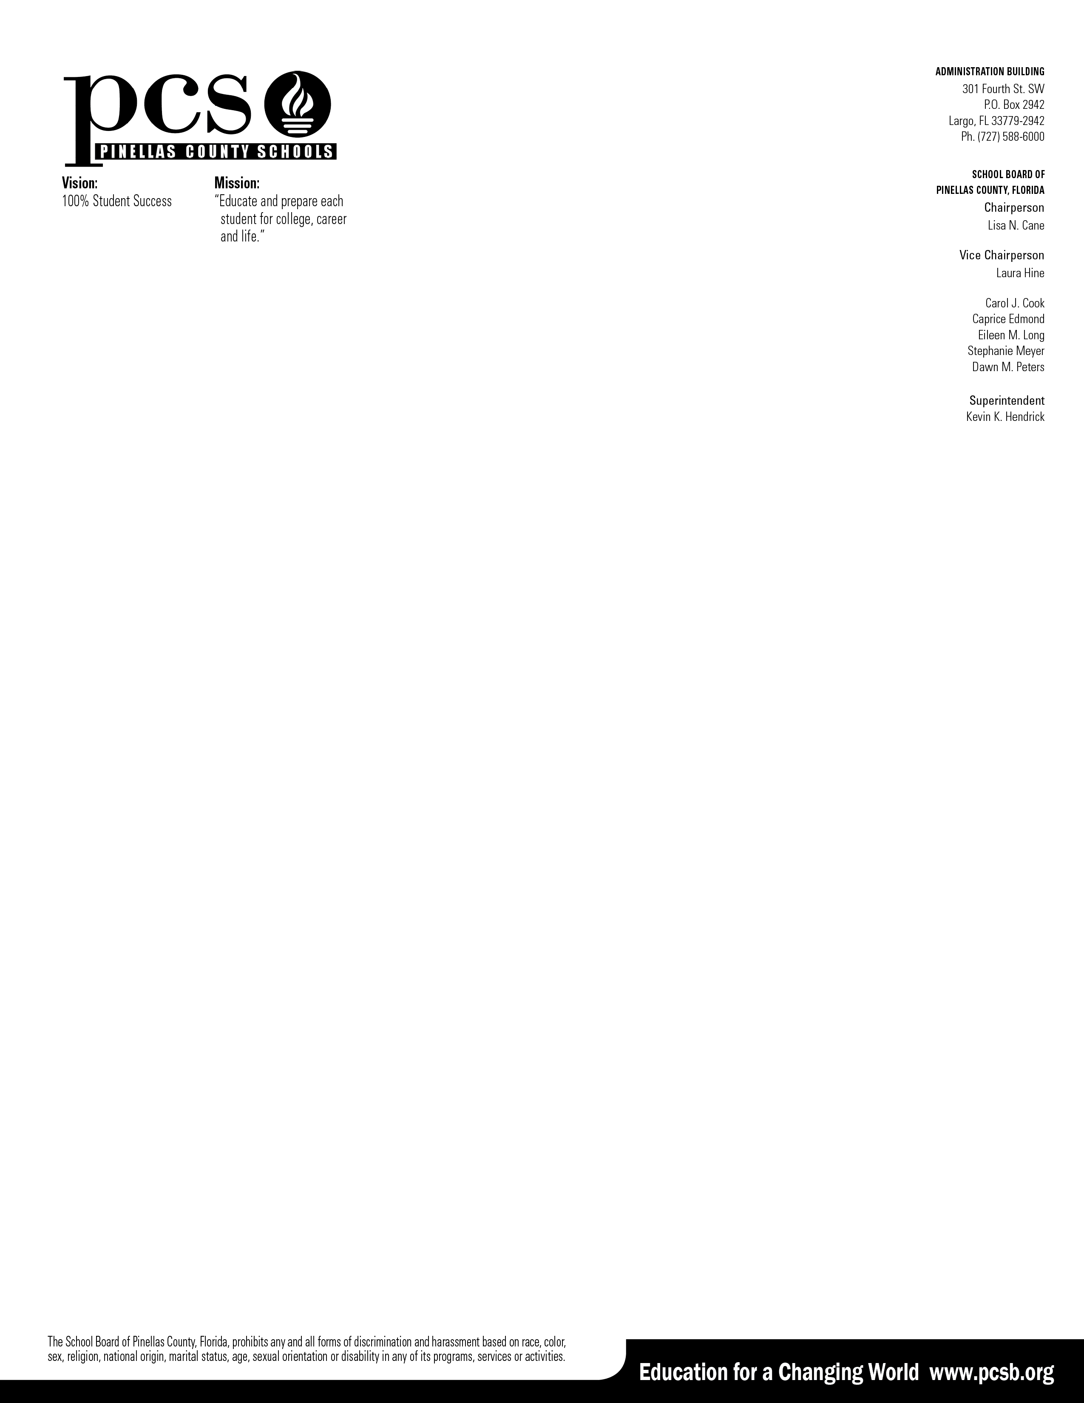

September 1, 2023

Dear Parent & Student,

On behalf of Pinellas County Schools, I would like to announce that the Preliminary SAT/National Merit Scholarship Qualifying Test (PSAT/NMSQT) will be administered digitally to every 9th, 10th, and 11th grade student during the month of October.

The PSAT/NMSQT evaluates the skills each student has developed in mathematics and evidence-based reading and writing; and also provides the tools a student needs to reach his or her college goals. Because the PSAT/NMSQT evaluates the same skills as the SAT, taking this assessment is an effective way for a student to start getting ready for the SAT. Additionally, the PSAT/NMSQT gives each student personalized feedback about their academic strengths and weaknesses, helping each student to prepare for success in college and careers. A score of 430 on the math section also provides students with an Algebra 1 EOC concordant score needed for graduation requirements.

Every student who takes the PSAT/NMSQT is given access to multiple online resources that provide personalized SAT preparation, as well as college and career planning tools – all at no cost to the student or their family. These resources include:

* A PSAT/NMSQT score report that includes answers with detailed explanations.
* A personalized SAT study plan when the student links their PSAT results to the Khan Academy SAT Prep site.
* A detailed personality test to help students identify interests and find majors and/or careers that are a good fit
* A personalized list of colleges to consider based on the student’s home state and intended major.
* A report that shows the Advanced Placement courses in which the student shows the opportunity to be successful.

One additional way that a student can benefit from participation in this assessment in 9th and 10th grade is by performing stronger on the assessment in 11th grade. Students who take the PSAT/NMSQT in 11th grade may be eligible to enter competitions for college scholarships and other academic recognition programs. Additional information regarding these programs will be provided to you during the spring of the 10th grade year in preparation for the upcoming test in the fall of the 11th grade year.

Parents, we appreciate your support of this assessment as your student continues their journey through high school and beyond.

Students, we hope you will put forth your best effort on test day, to allow us to support your unique needs on your journey toward college and career success.

Respectfully,

Cassandra Bogatz, Director, Advanced Studies & Academic Excellence

If you want your child to take the PSAT/NMSQT, there is nothing to do. You do not have to return the form.

If you ***do not*** want your child to take the PSAT/NMSQT, please complete the form below and return it to Mrs. Dolan’s office (2-114) or email it back at [doland@pcsb.org](mailto:doland@pcsb.org):

I ***do not*** want my child to take the PSAT/NMSQT.

Student Name: ____________________________________________________ Date: __

Parent/Guardian Name: _____________________________________________

Parent/Guardian Signature: